Main logo of Maa Yashoda in beginning
At first the partners are there which are repeating at bottom also which is better so need to keep it
Need to add logo in partners
Rotary Club of Shades Valley ( shared previously )
Rotary District 3060
Rotary District 3142
Rotary District 6860
Chhanyado
Surat Pediatric Association Charitable Trust

Academy of Pediatrics Gujarat
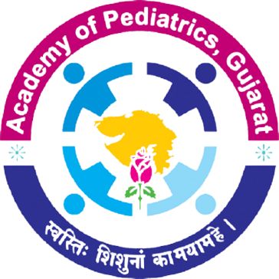

Indian Academy of Pediatrics
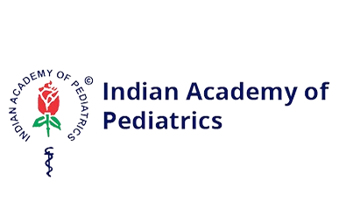
At the contact
Dr. Prashant Kariya – Photo
Email – drprashantkariya@gmail.com

